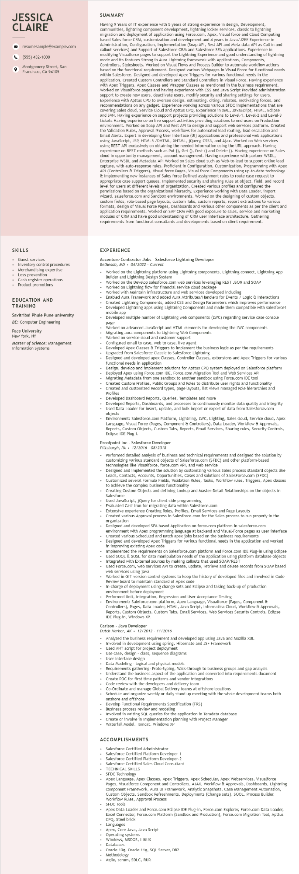
JESSICA CLAIRE
9
resumesample@example.com
(555) 432-1000
Montgomery Street, San
Francisco, CA 94105
SUMMARY
Having 9 Years of IT experience with 5 years of strong experience in design, Development, communities, lightning component development, lightning locker services, classic to lightning migration and deployment of application using Force.com, Apex, Visual force and Cloud Computing based Sales force CRM, customization and development and 4 years in Java/J2EE Experience in Administration, Configuration, Implementation (Soap API, Rest API and Meta data API as Call in and callout services) and Support of Salesforce CRM and Salesforce SFA applications. Experience in modifying Visualforce pages to to support the Lightning Experience and good understanding of lightning mode and its features Strong in Aura Lightning framework with Applications, Components, Controllers, Stylesheets. Worked on Visual Flows and Process Builder to automate workflow actions based on the functional requirement. Designed various Webpages in Visual Force for functional needs within Salesforce. Designed and developed Apex Triggers for various functional needs in in the application. Created Custom Controllers and Standard Controllers in Visual Force. Having experience with Apex Apex Triggers, Apex Classes and Wrapper Classes as mentioned in the business requirement. Worked on Visualforce pages and having experie experience with CSS and Java Script Provided administration support to create new users, deactivate users, modify security and sharing settings for users.
ons
Experien erience with Apttus CPQ to oversee design, estimating, citing, rebates, motivating forces, and recommendations on any gadget. Experience working across various SFDC implementations that are covering Sales cloud, Service Cloud and Apttus CPQ. Experience in XML, JavaScript, HTML, Eclipse and SVN. Having experience on support projects providing solutions to Level-1, Level-2 and Level-3 tickets Having experience on live support activities providing solutions to end users on Production environment. Worked on Soap API and Rest API to design and support web services platform. Created the Validation Rules, Approval Process, workflows for automated lead routing, lead escalation and Email Alerts. Expert in developing User Interface (UI) applications and professional web applications wee application Worked using JavaScript, JSP, HTML5/DHTML, XHTML, jQuery, CSS3, and Ajax. Worked on Web services using REST API exclusively on obtaining the needed information using the URL approach. experience on REST methods such as Put (), Get (), Post () and Delete (). Having experience on Sales cloud in opportunity management, account management. Having experience with partner WSDL,
ch. Having
online lead
Enterprise WSDL and Metadata API Worked on Sales cloud such as Web-to-lead to supping with Apex
capture, with auto-response rules. Proficient in Configuration, Customization, Programming API (Controllers & Triggers), Visual force Pages, Visual force Components using up-to-date technology & implementing new instances of Sales force Defined assignment rules to route case case request to appropriate case support queues. Implemented security and sharing rules at object, field, and record level for users at different levels of organization, Created various profiles and configured the permissions based on the organizational hierarchy. Experience working with Data Loader, import wizard, salesforce.com and Sandbox environments. Worked on the designing of custom objects, custom fields, role-based page layouts, custom Tabs, custom reports, report extractions to various formats, design of Visual Force Pages, Dashboards and various other components as per the client and application requirements. Worked on SAP CRM with good exposure to sales, service and marketing modules of CRM and have good understanding of CRM user interface architecture. Gathering requirements from functional consultants and developments based on client requirement.
SKILLS
Guest services
• Inventory control procedures
• Merchandising expertise
• Loss prevention
• Cash register operations
• Product promotions
EDUCATION AND TRAINING
Savitribai Phule Pune university
BE: Computer Engineering
Pace University
New York, NY
Master of Science: Management Information Systems
EXPERIENCE
Accenture Contractor Jobs - Salesforce Lightning Developer
Bethesda, MD 04/2022 - Current
Worked on the Lightning platform using Lightning components, Lightning connect, Lightning App Builder and Lightning Design System
Worked on the Develop salesforce.com web services leveraging REST JSON and SOAP
Worked on Lightning flow for financial service cloud package
Worked with Maintain infrastructure and web services developed including
Enabled Aura Framework and added Aura Attributes/Handlers for Events / Logic & Interactions
Created Lightning Components, added CSS and Design Parameters which improves performance Developed Lightning apps using Lightning Components and made them compatible with salesforce1 mobile app
Developed multiple number of Lightning web components (LWC) regarding service case console
page
Worked on advanced JavaScript and HTML elements for developing the LWC components Migrating aura components to Lightning Web Components
Worked on service cloud and customer support
Configured email to case, web to case, live agent
Developed Apex Classes & Triggers to implement the business logic as per the requirements Upgraded from Salesforce Classic to Salesforce Lightning
Designed and developed apex Classes, Controller Classes, extensions and Apex Triggers for various functional needs in application
Design, develop and implement solutions for Apttus CPQ system deployed on Salesforce platform Deployed Apex using Force.com IDE, Force.com Migration Tool and Web Services API
Migrating Metadata from one sandbox to another sandbox using Force.com IDE tool
Created Custom Profiles, Public Groups and Roles to distribute user rights and functionality
Created and customized Record types, page layouts, list views managed Role hierarchies and Profiles Profiles
Developed Dashboard Reports, Queries, Templates and more
Developed Reports, Dashboards, and processes to continuously monitor data quality and integrity Used Data Loader for insert, update, and bulk import or export of data from Salesforce.com objects
Environment: Salesforce.com Platform, Lightning, LWC, Lighting, Sales cloud, Service cloud, Apex Language, Visual Force (Pages, Component & Controllers), Data Loader, Workflow & Approvals, Reports, Custom Objects, Custom Tabs, Reports, Email Services, Sharing rules, Security Controls, Eclipse IDE Plug-i.
Proofpoint Inc - Salesforce Developer
Pittsburgh, PA 12/2016 08/2018
• Performed detailed analysis of business and technical requirements and designed the solution by customizing various standard objects of Salesforce.com (SFDC) and other platform-based technologies like Visualforce, force.com API, and web service
Designed and implemented the solution by customizing various Sales process standard objects like Leads, Contacts, Accounts, Opportunities, Cases and solutions of SalesForce.com (SFDC)
Customized several Formula Fields, Validation Rules, Tasks, Workflow rules, Triggers, Apex classes to achieve the complex business functionality
Creating Custom Objects and defining Lookup and Master-Detail Relationships on the objects in Salesforce
Used JavaScript, jQuery for client side programming
Evaluated Cast Iron for migrating data within Salesforce.com
Extensive experience Creating Roles, Profiles, Email Services and Page Layouts
Created
various Approval process in Salesforce.com for the Sales process to run properly in the organization
Designed and developed SFA based Application on force.com platform in salesforce.com environment with Apex programming language at backend and Visual-Force pages as user interface Created various Scheduled and Batch apex jobs based on the business requirements
• Designed and developed Apex Triggers for various functional needs in the application and worked in improving existing Apex code
implemented the Implemented the requirements on Salesforce.com platform and Force.com IDE Plug-in using Eclipse Used SOQL & SOSL for data manipulation needs of the application using platform database objects Integrated with External sources by making callouts that used SOAP/REST
Used Force.com, web services API to create, update, retrieve and delete records from SOAP based web services using java
Worked in GIT version control systems to keep the history of developed files and involved in Code Review board to maintain standard of Apex code
In-charge of deployment using change sets and Eclipse and taking back-up of production environment before deployment
Performed Unit, Integration, Regression and User Acceptance Testing
Environment: Saleforce.com platform, Apex Language, Visualforce (Pages, Component & Controllers), Pages, Data Loader, HTML, Java Script, Informatica Cloud, Workflow & Approvals,
Reports, Custom Objects, Custom Tabs, Email Services, Web Services Security Controls, Eclipse IDE Plug-in, Windows XP.
Carlson Java Developer
Dutch Harbor, AK 12/2012 - 11/2016
• Analyzed the business requirement and developed app using Java and Mozilla XUL
Involved in development using spring, Hibernate and JSF Framework
Used ANT script for project deployment
Use case, design - class, sequence diagrams
User Interface design
Data Modeling - logical and physical models
Requirements gathering-Proto-typing, Walk-through to business groups and gap analysis
Understand the business aspect of the application and converted into requirements document
Create POC for first time patterns and vendor integrations
Code review with the developers and delivery team
nate and manage Global Delivery teams at offshore locations
Co-Ordinate and
Schedule and organize weekly or daily stand up meeting with the whole development teams both onshore and offshore
Develop Functional Requirements Specification (FRS)
Business process review and modeling
Involved in writing SQL queries for the application in Teradata database
Create or involve in Implementation planning with Project Manager
Waterfall Model, Tomcat, Windows XP
.......
ACCOMPLISHMENTS
Salesforce Certified Administrator
Salesforce Certified Platform Developer-1
Salesforce Certified Platform Developer-2 Salesforce Certified Sales Cloud Consultant
TECHNICAL SKILLS
SFDC
Technology
Apex Language, Apex Classes, Apex Triggers, Apex Scheduler, Apex Webservices, Visualforce Pages, Visualforce Component and Controllers, AJAX, Workflow & Approvals, Dashboards, Lightning component Framework, Aura UI Framework, Analytic Snapshots, Case Management Automation, Custom Objects, Sandbox Refreshments, Deployments (Change sets), SOQL, Process Builder, Workflow Rules, Approval Process
SFDC Tools
• Apex Data Loader and Force.com Eclipse IDE Plug-in, Force.com Explorer, Force.com Data Loader, Excel Connector, Force.com Platform (Sandbox and Production), Force.com Migration Tool, Apttus CPQ, Steel brick
Languages
Apex, Core Java, Java Script
Operating systems
Windows, MSDOS, LINUX
Databases
Oracle 10g, Oracle 11g, SQL Server, DB2
Methodology
Agile, scrum, SDLC, RUP.

